Student Record Management System

MINI PROJECT REPORT

Technical Training (25CAP-652)

Submitted By

Anubhav Yadav (25MCD10057)

in partial fulfillment for the award of the degree of

Master of Computer Applications
In
Data Science


Chandigarh University
April 2026

ACKNOWLEDGEMENT

I, Anubhav Yadav (UID: 25MCD10057), a 1st Year student of MCA (Data Science), would like to express my sincere gratitude to all those who supported and guided me in the successful completion of my project titled “Student Record Management System.”
Firstly, I would like to thank the Department of Computer Applications, UIC (University Institute of Computing), Chandigarh University, and all my faculty members for their constant guidance, motivation, and encouragement throughout the development of this project. Their insights into programming concepts, especially in C language and problem-solving approaches, played a vital role in shaping this work.
I would also like to express my special thanks to my project mentor, Mr. Chanchal Sharma, for his valuable guidance, constructive feedback, and continuous support during the entire development process. Her suggestions helped me improve both the logic implementation and overall structure of the project.
My heartfelt thanks to my classmates and friends for their cooperation and meaningful discussions, which contributed to enhancing the functionality and user interface aspects of the system.
Lastly, I am deeply thankful to my family for their unwavering support, encouragement, and belief in me throughout my academic journey.
This project was primarily developed using the C programming language with concepts such as structures, file handling, and menu-driven design. Additionally, a basic frontend dashboard was designed using HTML, CSS, JavaScript, and Bootstrap to demonstrate how the system can be extended into a full-stack application. I also acknowledge the availability of open-source resources and tools that made the development process more efficient and effective.

TABLE OF CONTENT
- Abstract
1.1 Overview of the Project
1.2 Objective of the Project

- Introduction
2.1 Background of the Study
2.2 Motivation for the Project
2.3 Problem Statement
2.4 Scope of the Project

- System Requirements
3.1 Hardware Requirements
3.2 Software Requirements

- System Design and Architecture
4.1 Overall System Architecture
4.2 Data Flow Diagram (DFD)
4.3 Program Structure (Modules in C)

- Core Implementation (C Programming)
5.1 Structure Definition (Student Record)
5.2 File Handling Mechanism
5.3 Menu-Driven Interface
5.4 Functional Modules
• Add Student
• View Students
• Search Student
5.5 Algorithm / Logic Flow

- User Interface Design
6.1 Console-Based UI (C Program)
6.2 Frontend Dashboard Overview (HTML, CSS, Bootstrap)

- Results and Output
7.1 Output of C Program
7.2 Frontend Dashboard Screens
7.3 System Testing

- Conclusion and Future Scope
8.1 Conclusion
8.2 Future Enhancements
8.3 GitHub Repository Link
- References
- ABSTRACT
1.1 Overview of the Project
The “Student Record Management System” is a mini project developed using the C programming language to efficiently manage student-related information in a structured manner. The system provides a simple and interactive menu-driven interface through which users can perform operations such as adding new student records, viewing existing records, and searching for specific student details. Each record contains essential information including roll number, name, and marks.
The project makes use of file handling techniques in C to store data permanently, allowing users to access and manage records even after the program is restarted. The console-based user interface is designed with basic styling to improve readability and user experience.
1.2 Objective of the Project
The primary objective of this project is to implement a basic data management system using fundamental C programming concepts such as structures, functions, and file handling. It aims to strengthen understanding of how data can be stored, retrieved, and manipulated efficiently in a real-world scenario.
Additionally, the project includes a simple frontend dashboard developed using HTML, CSS, JavaScript, and Bootstrap to demonstrate how the system can be visually represented and extended into a full-stack application in the future.

- INTRODUCTION
2.1 Background of the Study
Managing student records manually can be time-consuming and prone to errors, especially when dealing with large amounts of data. With the increasing need for digital solutions, simple software systems can help in organizing and maintaining records efficiently. The C programming language provides a strong foundation for building such systems using basic programming concepts and file handling techniques.
2.2 Motivation for the Project
The motivation behind this project is to understand how real-world data management systems work at a fundamental level. By developing this system in C, it helps in strengthening core programming skills and logic building. Additionally, creating a simple frontend dashboard gives an idea of how such systems can be visually enhanced for better user interaction.
2.3 Problem Statement
The main problem addressed in this project is the difficulty in managing student records manually or in an unorganized manner. There is a need for a system that can store, retrieve, and manage student data efficiently, while minimizing errors and saving time.
2.4 Scope of the Project
The scope of this project includes developing a console-based application that allows users to perform basic operations such as adding, viewing, and searching student records. The system uses file handling for data storage. A basic frontend dashboard is also designed to demonstrate how the system can be extended into a more interactive and user-friendly application in the future.

- SYSTEM REQUIREMENTS
3.1 Hardware Requirements
The system does not require high-end hardware and can run on a basic computer system. The minimum hardware requirements are:
- Processor: Intel i3 or equivalent
- RAM: 4 GB or higher
- Storage: At least 500 MB free disk space
- Input Devices: Keyboard and mouse
3.2 Software Requirements
The project is developed using simple and widely available software tools. The requirements are:
- Operating System: Windows / Linux / macOS
- Programming Language: C
- Compiler: GCC or any standard C compiler (e.g., Turbo C)
- Code Editor/IDE: VS Code / CodeBlocks / Dev C++
- Frontend Tools (for dashboard): HTML, CSS, JavaScript, Bootstrap

- SYSTEM DESIGN AND ARCHITECTURE
4.1 Overall System Architecture
The system follows a simple architecture where the user interacts with a console-based interface developed in C. The application processes user inputs and performs operations such as adding, viewing, and searching student records. All data is stored in a file, which acts as the storage layer, ensuring data persistence.
In addition, a separate frontend dashboard is designed using HTML, CSS, JavaScript, and Bootstrap to represent how the system can be extended into a graphical interface. However, it is not directly connected to the C program.
4.2 Data Flow Diagram (DFD)
The data flow of the system begins with user input through the menu-driven interface. Based on the selected option, the system processes the request and interacts with the file storage. Data is either written to the file (in case of adding a student) or read from the file (in case of viewing or searching records). The processed data is then displayed back to the user.
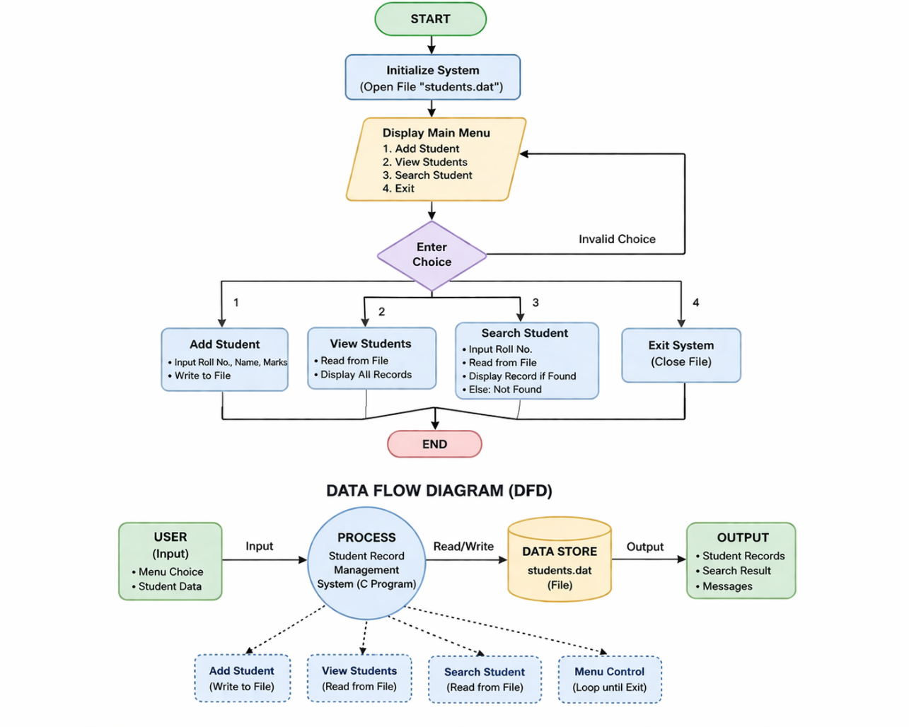
This flow ensures smooth interaction between the user, program logic, and data storage.
4.3 Program Structure (Modules in C)
The system is divided into different functional modules for better organization and readability:
- Main Menu Module: Handles user interaction and navigation
- Add Student Module: Accepts and stores new student records
- View Students Module: Displays all stored records
- Search Module: Finds a student record based on roll number
- File Handling Module: Manages reading and writing of data
This modular approach makes the program easy to understand, maintain, and extend.
- CORE IMPLEMENTATION (C PROGRAMMING)
5.1 Structure Definition (Student Record)
The system uses a structure to represent student data. Each student record contains fields such as roll number, name, and marks. This allows efficient grouping and handling of related data in the program.
5.2 File Handling Mechanism
File handling is used to store and manage student records permanently. The program uses binary file operations such as fopen(), fwrite(), and fread() to write and read data from a file. This ensures that the data remains saved even after the program is closed and can be accessed later when required.
Code (C Program):
#include <stdio.h>
#include <stdlib.h>
#include <string.h>

#define FILE_NAME "students.txt"

struct Student {
int roll;
char name[50];
float marks;
};

// 🎨 UI FUNCTIONS
void clearScreen() {
system("cls || clear");
}

void printLine() {
printf("============================================\n");
}

void printTitle() {
printLine();
printf(" STUDENT MANAGEMENT SYSTEM\n");
printLine();
}

// ➕ ADD STUDENT
void addStudent() {
FILE *fp = fopen(FILE_NAME, "ab");
struct Student s;

clearScreen();
printTitle();

printf("Enter Roll Number: ");
scanf("%d", &s.roll);

printf("Enter Name: ");
scanf(" %[^\n]", s.name);

printf("Enter Marks: ");
scanf("%f", &s.marks);

fwrite(&s, sizeof(s), 1, fp);
fclose(fp);

printf("\n Student Added Successfully!\n");
printf("Press Enter to continue...");
getchar(); getchar();
}

// 📋 VIEW STUDENTS
void viewStudents() {
FILE *fp = fopen(FILE_NAME, "rb");
struct Student s;

clearScreen();
printTitle();

printf("%-10s %-20s %-10s\n", "ROLL", "NAME", "MARKS");
printLine();

while (fread(&s, sizeof(s), 1, fp)) {
printf("%-10d %-20s %-10.2f\n", s.roll, s.name, s.marks);
}

fclose(fp);

printf("\nPress Enter to continue...");
getchar(); getchar();
}

// 🔍 SEARCH STUDENT
void searchStudent() {
FILE *fp = fopen(FILE_NAME, "rb");
struct Student s;
int roll, found = 0;

clearScreen();
printTitle();

printf("Enter Roll Number to Search: ");
scanf("%d", &roll);

while (fread(&s, sizeof(s), 1, fp)) {
if (s.roll == roll) {
printf("\n Student Found!\n");
printLine();
printf("Roll : %d\n", s.roll);
printf("Name : %s\n", s.name);
printf("Marks : %.2f\n", s.marks);
printLine();
found = 1;
break;
}
}

if (!found) {
printf("\n Student Not Found!\n");
}

fclose(fp);

printf("\nPress Enter to continue...");
getchar(); getchar();
}

// 🏠 MAIN MENU
void menu() {
int choice;

while (1) {
clearScreen();
printTitle();

printf("1. Add Student\n");
printf("2. View Students\n");
printf("3. Search Student\n");
printf("4. Exit\n");

printLine();
printf("Enter your choice: ");
scanf("%d", &choice);

switch (choice) {
case 1:
addStudent();
break;
case 2:
viewStudents();
break;
case 3:
searchStudent();
break;
case 4:
printf("\n Exiting... Thank you!\n");
exit(0);
default:
printf("\n Invalid Choice!");
getchar(); getchar();
}
}
}

// 🚀 MAIN FUNCTION
int main() {
menu();
return 0;
}

5.3 Menu-Driven Interface
A menu-driven approach is implemented to provide an easy-to-use interface for users. The main menu displays different options such as adding a student, viewing all students, searching for a student, and exiting the program. The user selects an option, and the corresponding function is executed.
5.4 Functional Modules
The system is divided into different functional modules:
- Add Student: This module allows the user to enter student details and store them in the file.
- View Students: This module reads all records from the file and displays them in a formatted manner.
- Search Student: This module searches for a specific student using the roll number and displays the result if found.
Each module is implemented using separate functions to improve code organization and readability.
5.5 Algorithm / Logic Flow
The overall logic of the system begins with displaying the main menu. Based on user input, the program calls the respective function. For adding records, data is taken from the user and written to the file. For viewing or searching, data is read from the file and displayed accordingly. The program continues to run in a loop until the user chooses to exit.
This structured approach ensures smooth execution and efficient handling of student data.

- USER INTERFACE DESIGN
6.1 Console-Based UI (C Program)
The system uses a menu-driven console interface developed in C, which allows users to interact with the program easily. The interface displays a structured menu with options such as adding a student, viewing records, searching for a student, and exiting the system.
Basic styling techniques like formatted output, spacing, and separators are used to improve readability. The user navigates through the system by entering choices, making the interface simple and user-friendly.
6.2 Frontend Dashboard Overview (HTML, CSS, Bootstrap)
A basic frontend dashboard is designed using HTML, CSS, JavaScript, and Bootstrap to visually represent the system. The dashboard includes pages such as a main dashboard, add student form, and view students table.
This frontend is not directly connected to the C program but demonstrates how the system can be extended into a graphical and more interactive application in the future.

- RESULTS AND OUTPUT
7.1 Output of C Program

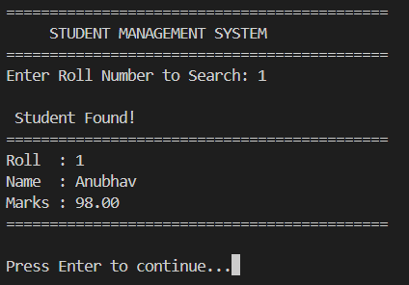
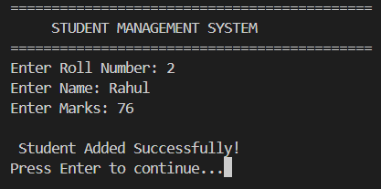
The C-based Student Record Management System was successfully implemented and tested. The program allows users to add new student records, view all stored records, and search for specific students using their roll number. The output is displayed in a well-structured format on the console, making it easy to read and understand.
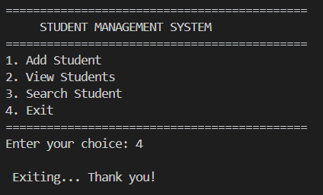
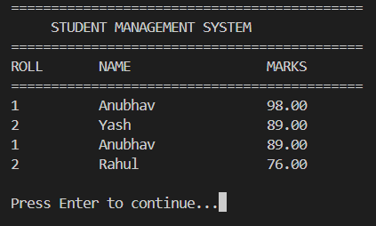
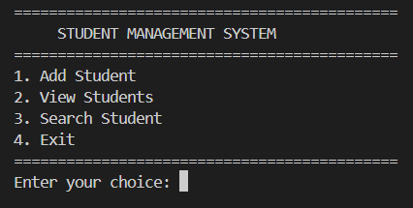
The C-based Student Record Management System was successfully implemented and tested. The program allows users to add new student records, view all stored records, and search for specific students using their roll number. The output is displayed in a well-structured format on the console, making it easy to read and understand.
The file handling mechanism ensures that all data is stored permanently and can be accessed even after restarting the program.
7.2 Frontend Dashboard Screens
A simple frontend dashboard was designed using HTML, CSS, JavaScript, and Bootstrap to represent how the system would look in a graphical environment. It includes pages such as a dashboard view, add student form, and student records table with dummy data.
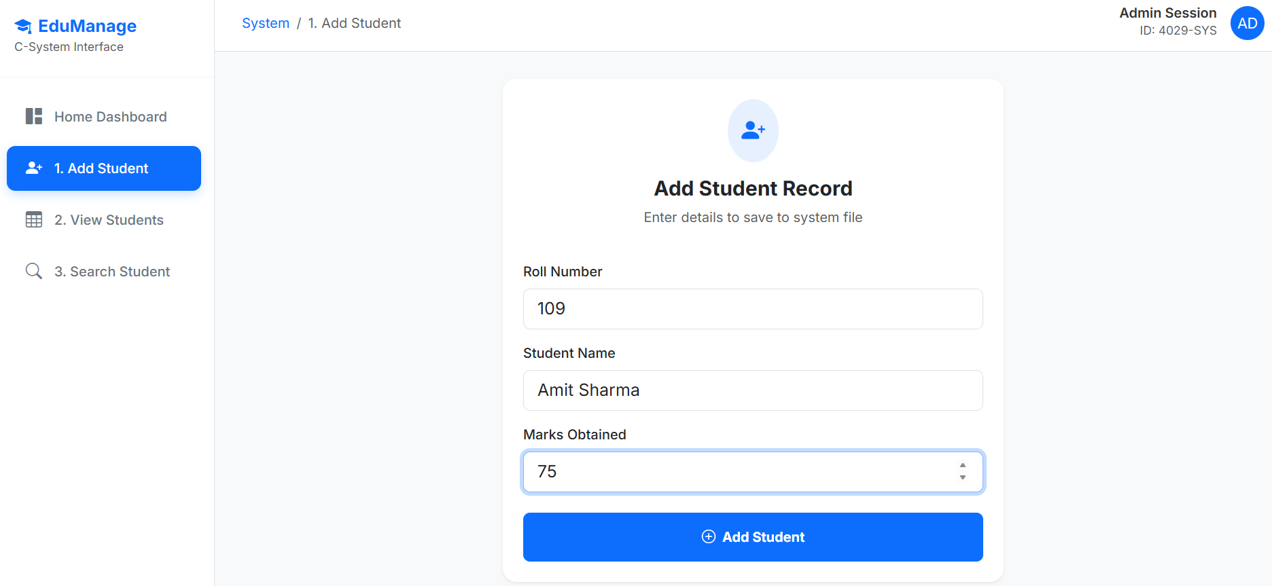
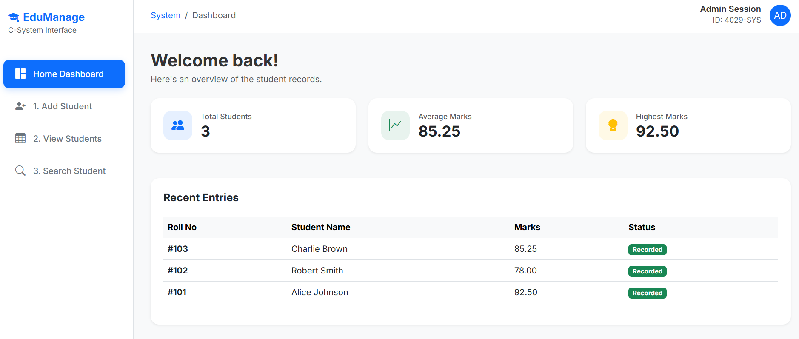
This provides a visual understanding of how the system can be extended into a more user-friendly interface.
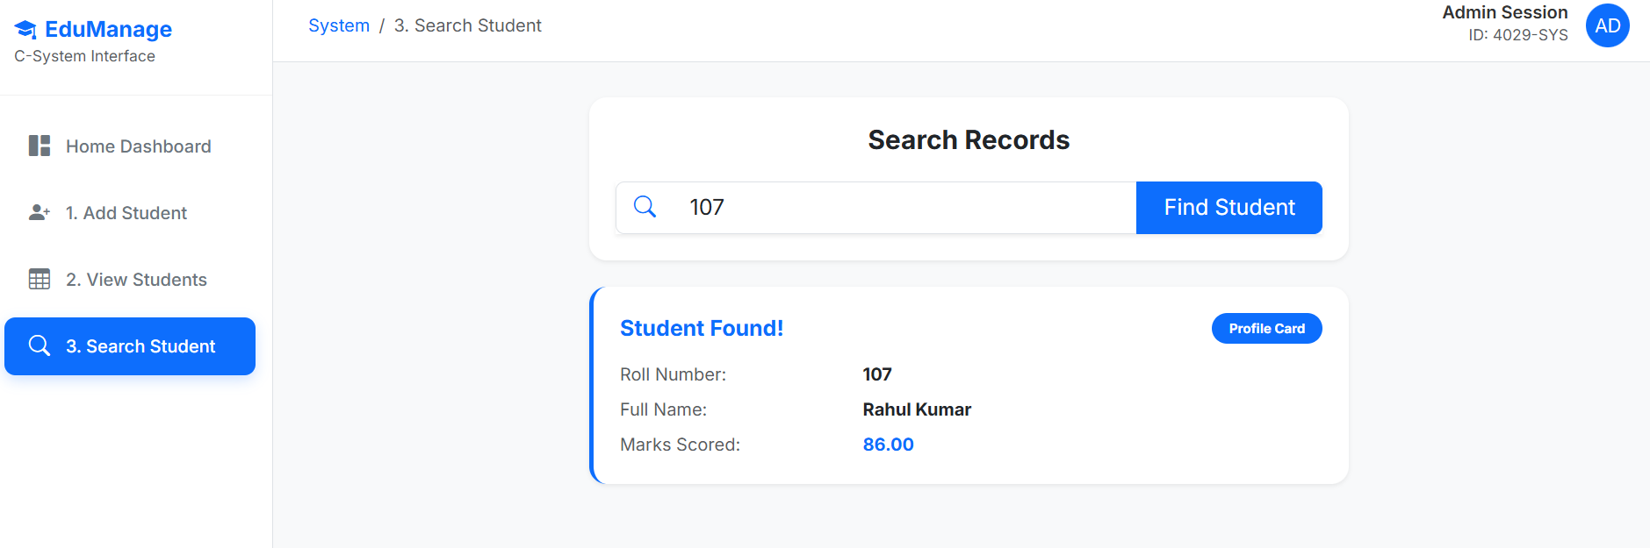
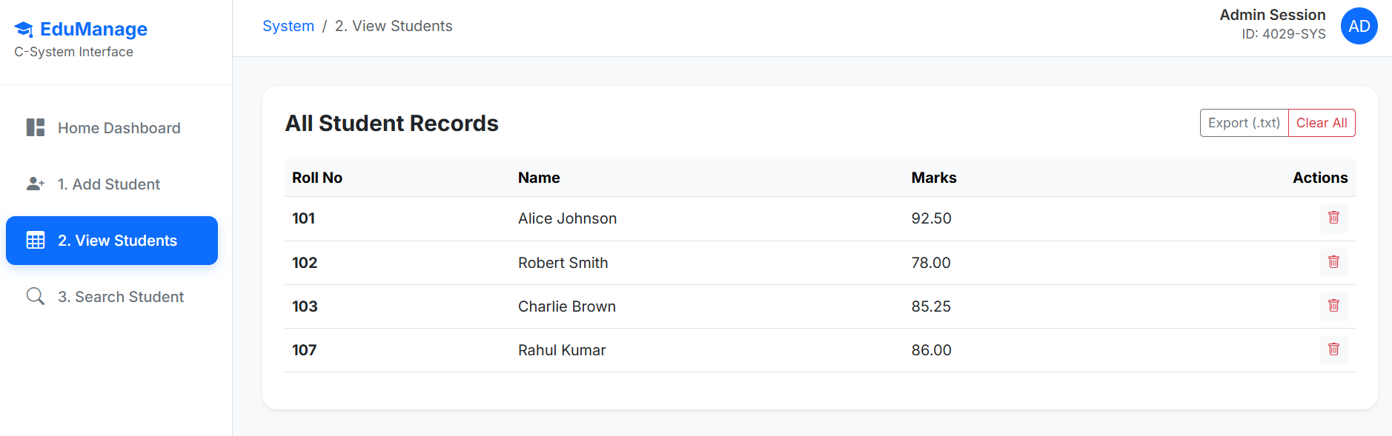

7.3 System Testing
The system was tested with different inputs to ensure proper functionality. All features, including adding, viewing, and searching records, were verified to work correctly. Invalid inputs and edge cases were also checked to ensure the system handles them appropriately without errors.

- CONCLUSION AND FUTURE SCOPE
8.1 Conclusion
The “Student Record Management System” was successfully developed using the C programming language. The project demonstrates the use of fundamental concepts such as structures, file handling, and menu-driven programming to manage student data efficiently.
The system provides a simple and effective way to store, retrieve, and search student records. The additional frontend dashboard gives an idea of how the system can be extended into a more interactive and user-friendly application.
8.2 Future Enhancements
The project can be further improved by adding features such as update and delete operations for student records. Security features like user authentication can also be implemented.
In the future, the system can be fully integrated with a graphical user interface or a web-based application connected to a proper database, making it more scalable and efficient.
8.3 GitHub Repository Link
Link: https://github.com/AnubhavDataSci25/Technical-Training-Mini-Project-Sem-2

- REFERENCE

- Kernighan, B. W., & Ritchie, D. M., The C Programming Language, Prentice Hall.
- TutorialsPoint, “C Programming Tutorial”, Available at: https://www.tutorialspoint.com/cprogramming/
- GeeksforGeeks, “C Programming Language”, Available at: https://www.geeksforgeeks.org/c-programming-language/
- W3Schools, “HTML, CSS, JavaScript Tutorials”, Available at: https://www.w3schools.com/
- Bootstrap Documentation, Available at: https://getbootstrap.com/docs/
- Various online resources and documentation for understanding file handling and basic frontend development.

